Table of Contents
1.0 User story of Solar home 3
2.0 Wire frames & UI requirements: 4
3.0 Workflows 6

1.0 User story of Solar home
Title: New user Signup
As a: | New user
I want to: | I Have a capability to Login on the home page of Application
So that: | I can make profile and use service of Application
Acceptance  Criteria: | - On home page system shall display a signup button (referring Wireframe 1: Home page)  - On a click on signup button, system shall open a new page called “sign up Page”  - On a sign up page system shall display Mandatory fields (referring Wireframe 2: Signup page)  - Full Name: system shall allow user to enter full name information  - Phone Number: System shall allow user to enter 10 digit numeric Phone number  - Email: system shall display allow user to enter email  - Type of service: system shall display check box  - What you do?; system shall display check box  - After filling the mandatory fields system shall allow user to set Password in Alphanumeric with special characters.  - After user set the password system shall allow to confirm password  - After that system shall display a check box for term & condition.  - after checking the check box system allow user to click on Sign Up Button (referring Workflow 1: Signup Page)  - after clicking on a signup button system shall send the OTP to user Via entered phone Number/Email  - After sending OTP system shall display New page to enter OTP (referring Wireframe 3: OTP Page)  - After entering OTP system shall allow user to Click on Submit button  - After validating OTP system shall allow user to Login in the App.  - Alternate Flow 1: After clicking on a Sign up button System shall validate the data and if data is in-correct system shall display error on that field, after that system shall allow user to re-entered data in that field. (referring Workflow 1: Signup Page)  - Exceptional Flow 2: After clicking on a submit button in the OTP page system shall validate the OTP, If the entered OTP is incorrect then system shall display again signup page, and user have to re click on Signup button. (referring Workflow 1: Signup Page)

2.0 Wire frames & UI requirements:
2.1 Wireframe 2: Signup page
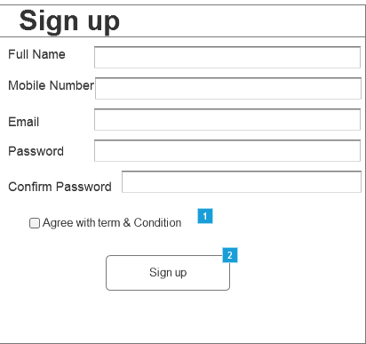
Note: After the Email field system shall display Type of service field, What you do? field

Field Name | Field Type | Content | Required  Field? | Min. Char. | Max  Char. | Notes
Full Name | Text Box | Alphabetic | Yes | N/A | N/A | N/A
Phone Number | Text Box | Numeric | Yes | 10 | 10 | N/A
Email | Text Box | Alpha-Numeric+ special character | Yes | N/A | N/A | N/A
Type of Service | Check Box | N/A | Yes | N/A | N/A | It should include:  - Solar  - Windmill  3)Electric Vehicle
What You do | Check Box | N/A | Yes | N/A | N/A | It should include:  - Vendor  - Seller  - Installer
Password | Text Box | Alpha-Numeric+ special character | yes | 8 | 16 | Entered password should be hidden
Confirm Password | Text Box | Alpha-Numeric+ special character | Yes | 8 | 16 | Entered password should be hidden

2.2 Wireframe 3: OTP page
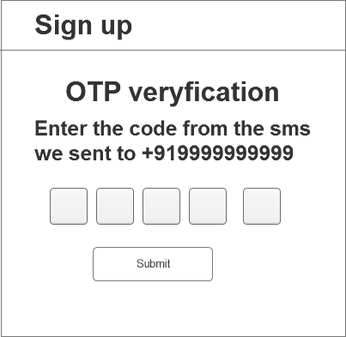

Field Name | Field Type | Content | Required  Field? | Min. Char. | Max  Char. | Notes
OTP | OTP Field | Numeric | Yes | N/A | 5 | It should be hidden
Submit | button | N/A | Yes | N/A | N/A | After clicking system shall validate the OTP

3.0 Workflows
3.1 New user registration
